**CREATING AN AWS ACCOUNT**

**Visit** **aws.amazon.com** **and click on “Create an AWS Account”**

**1.….**.

**Enter the root user email address ,AWS account name and click on “Verify email address”**

**2.**

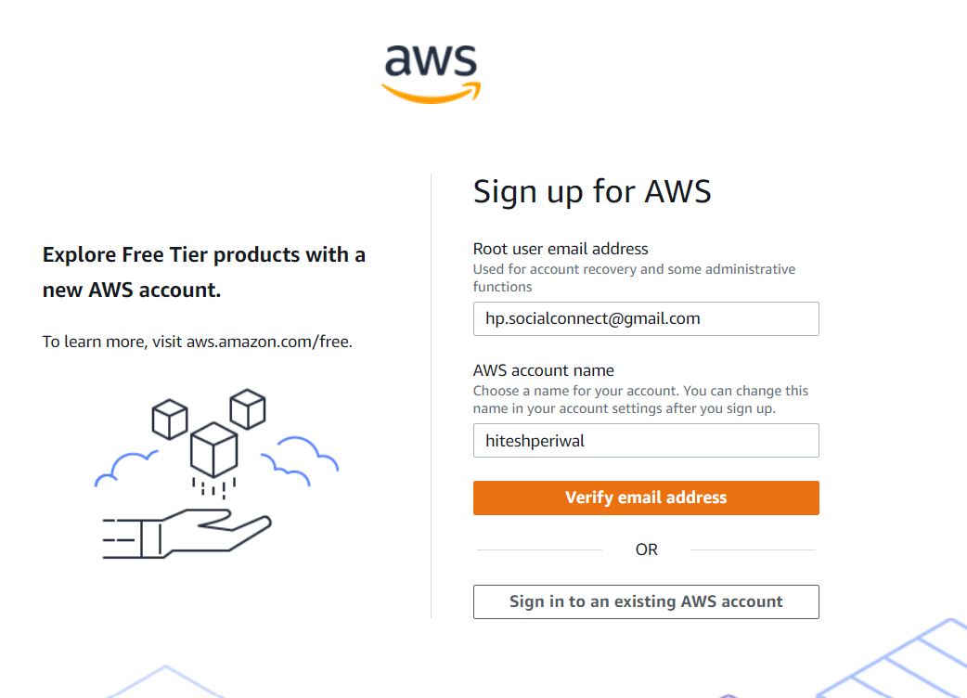

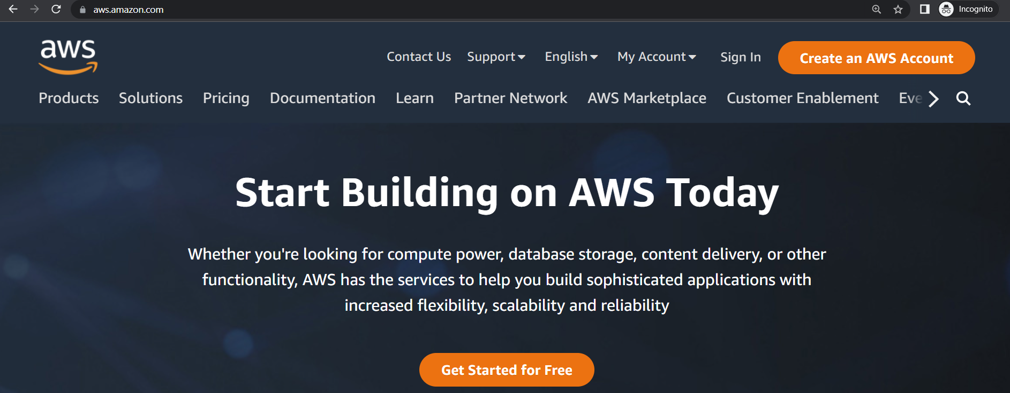

**Enter the verification code received in the given email address and click on “Verify”**

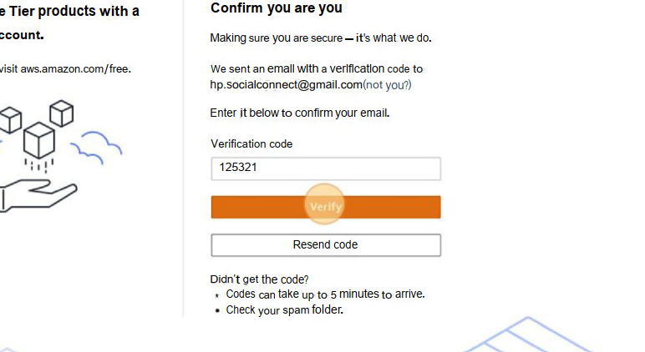

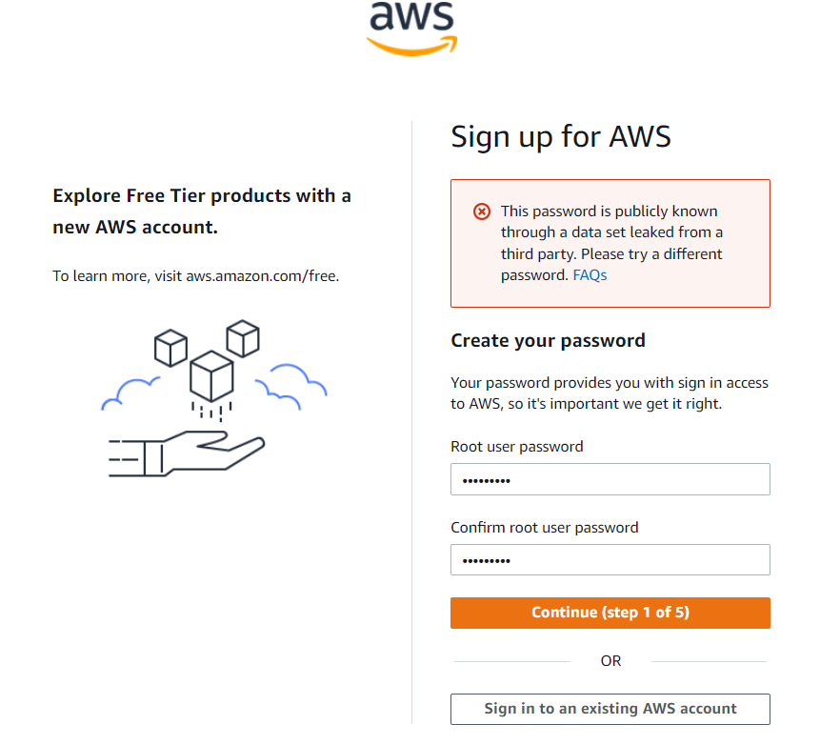

**3.**

**Set your account’s password**

**4.….**.

**Fill in your contact details and click on continue**

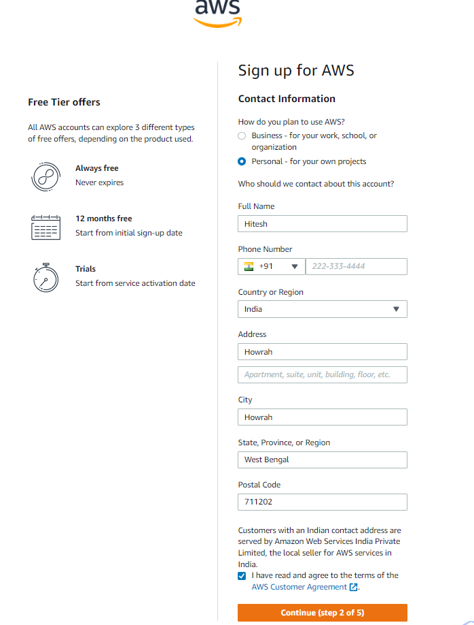

**5.….**.

**Enter your billing information and click on “Verify and Continue”**

**6.….**.

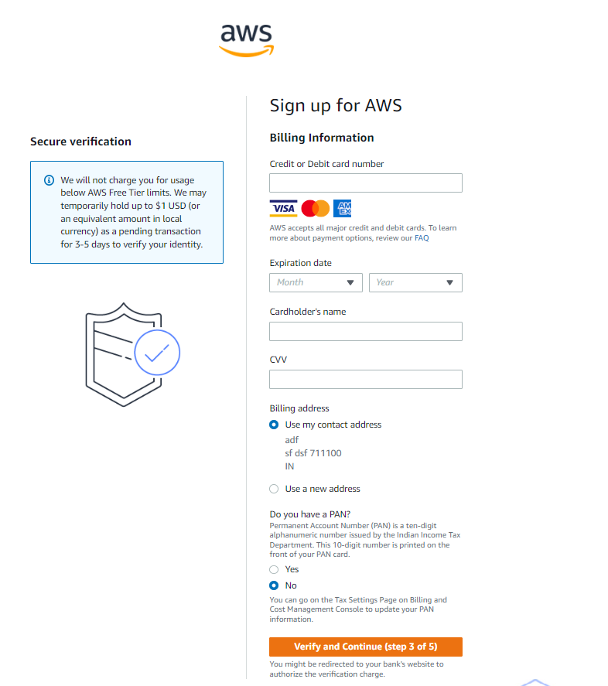

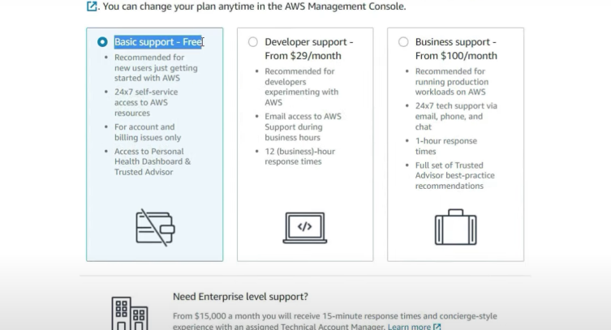

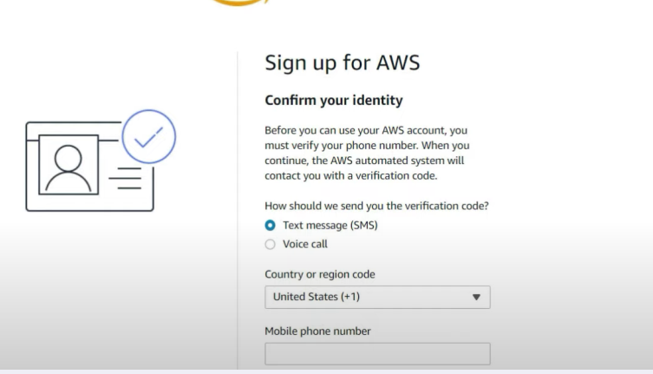

**Choose Basic Support plan and hence your AWS account is created**

**Confirm and verify your phone number**

**8.….**.

**7.….**.